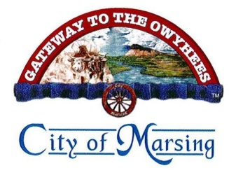

**City of Marsing**

**City Clerk**

**18 Sandbar AVE**

**PO Box 125**

**Marsing, ID 83639**

**208-896-4122 (O)**

**208-896-4123 (F)**

**Public Records Request**

The City of Marsing complies with the Idaho Public Records Act (Idaho Code § 9 – 338) for the public to examine and/or copy the following records. This request pertains to existing documents only. The City agrees to respond and deliver the requested records within three (3) days, but if necessary may, with written notification, take up to ten (10) days. By law, information gained through this request cannot be used for the purpose of compiling a mailing list or telephone list without obtaining permission from each individual.

|  |  |  |  |
| --- | --- | --- | --- |
| **Name** | | **Time** | **Date** |
| **Street Address** | | **Phone** | |
| **City, State** | | **Fax** | |
| **Signature** | | **Email** | |
| **Information Requested: (Be as specific as possible)**  I request to examine [ ] or copy [ ] the following records (must be specific records - name, date, or range of dates of document(s) you are requesting)  Delivery of copies are to be Hard [ ] or Electronic [ ] | | | |
| **Results/Findings – Staff Use only:** | | | |
| Staff providing information | Comments | | |

Email completed requests to office@marsingcity.com